THE ADVENTURE – 2023



ADVENT EVANGELICAL LUTHERAN CHURCH

Rev. Matthew E. Ollikainen, Pastor
OUR MISSION – FAITHFUL IN THE WORD
+ To gather as God’s people and nurture one another
+ To know the Word of God
+ To grow in faith, love, and service
+ To go into the world with the Good News of Jesus Christ

45 Worthington Mill Rd.
Richboro, PA 18954
215-355-2529
web: www.adventrichboro.org
e-mail: office@adventrichboro.org

Advent Evangelical Lutheran Church continues to worship indoors and online. Mask wearing at Advent is optional for the fully vaccinated and recommended for the unvaccinated and immunocompromised.

Based on Center for Disease Control, local governmental and church authorities’ recommendations, Advent continues to have these precautions:

-Respect for those who choose to mask or not mask
-Social distancing
-Sanitizing hands and objects handled
-Staying home if you have any symptoms of illness or have been in close contact with anyone with
COVID.
-The availability of online worship and the use of zoom for meetings.

Our leadership will continue to gauge the situation week by week and will keep the congregation informed of any adjustment to our precautions.

† † † † † † † † † † † † † † † † † † † † † † † †

SUNDAYS OF WORSHIP MARCH SCHDULE

MARCH 5
SECOND SUNDAY IN LENT
8:00 a.m. Traditional Holy Communion
9:00 a.m. Adult Bible Study
9:30 a.m. Contemporary Holy Communion
Sunday School age 4 - grade 6
10:30 a.m. Fellowship Time: George Henry
10:45 a.m. Adult Bible Study

MARCH 12
THIRD SUNDAY IN LENT
8:00 a.m. Traditional Holy Communion
9:00 a.m. Adult Bible Study
9:30 a.m. Contemporary Holy Communion
Sunday School age 4 - grade 6
10:30 a.m. Fellowship Time: The Dettra Fam
10:45 a.m. Church Council Meeting

MARCH 19
FOURTH SUNDAY IN LENT
8:00 a.m. Traditional Holy Communion
9:00 a.m. Adult Bible Study
9:30 a.m. Contemporary Holy Communion
Sunday School age 4 - grade 6
10:30 a.m. Fellowship Time: Open
10:45 a.m. Adult Bible Study

MARCH 26
FIFTH SUNDAY IN LENT
8:00 a.m. Traditional Holy Communion
9:00 a.m. Adult Bible Study
9:30 a.m. Contemporary Holy Communion
Sunday School age 4 - grade 6
10:30 a.m. Fellowship Time: Open
10:45 a.m. Adult Bible Study

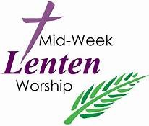
MID-WEEK LENTEN WORSHIP SERVICES THURSDAYS MARCH 2 - MARCH 30

“Beneath the Cross of Jesus” is the theme for worship this season of Lent. We live our lives beneath the cross of Jesus, beneath God’s manifold love and grace that reach to us even from Calvary. Based on the hymn “Beneath the cross of Jesus” (ELW 338), this series explores what it means for us to abide at the foot of the cross, to cling to the rock of our salvation, to dwell in the house of the Lord, and to confess our sins and receive God’s forgiveness.

Services will be held in person and online Thursday evenings at 7:00 p.m., March 2 through March 30.
Mid-week Lenten Worship services may also be attended by Zoom and will be live streamed on Facebook. A recording of the services will be uploaded to YouTube and linked to our website immediately after the service concludes. While using Zoom, please mute yourself when you are not speaking.
Meeting ID: 864 7772 3021
Pass code: 443360
https://us02web.zoom.us/j/86477723021?pwd=cEFHd2hxY0xMRVJPT2hCQjQ5MnF2Zz09

SUNDAY ONLINE WORSHIP INFORMATION
Sunday service may also be attended by Zoom and it will be live streamed on Facebook.
A recording of the service will be uploaded to YouTube and linked to our website immediately after the service concludes.

Regular Scheduled Zoom Services:

8:00 a.m. Topic: Advent Lutheran Church Traditional Holy Communion
Meeting ID: 891 9503 9877 Pass code: 443533
https://us02web.zoom.us/j/89195039877?pwd=dnVRTlRGamJQVXNZbENlVDJTT0pnUT09
9:30 a.m. Topic: Advent Lutheran Church Contemporary Holy Communion
Meeting ID: 854 0562 9972 Pass code: 506714
https://us02web.zoom.us/j/85405629972?pwd=aGErSFNlbVAvNmZsQkIzWVpTTktIQT09

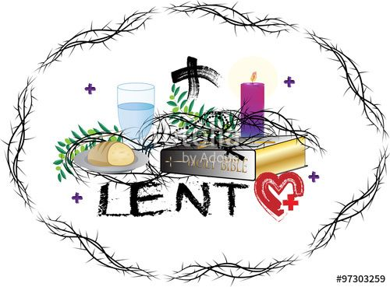
PASTOR MATT’S THOUGHTS FOR MARCH 2023

Observing the season of Lent is both an inward and outward thing that prepares us to celebrate the resurrection of Jesus Christ.

Observing Lent starts by looking inward with prayer and reflection. It is taking time to look at ourselves honestly. It is easy to get caught up in the moments of life without paying attention to ourselves in those moments. Without such self-reflection we can make assumptions of ourselves and others that might not be true. All too often those assumptions are ones that ignore our own shortcomings and needs. Admitting such things can be uncomfortable. Yet without looking at ourselves honestly, healing for our shortcomings and needs can be missed. Likewise, without looking at ourselves honestly, we can also miss out on seeing the preciousness that God sees in us. Looking inwardly reveals how much we need God to be forgiven, healed and loved.

Observing Lent is about looking outwardly. We are to look at those around us. We are to see the needs of those around us. We all are in need of forgiveness and of healing. We can be repulsed by and stand in judgement of the sin we see in others or we can confront that sin with truth and compassion. We are all in need of God’s love. By engaging in charity and almsgiving we both encounter and help address these needs. We become angels to those around us and those around us can become angels to us. Just as we are all sin and are in need of healing, we are all created in the image of God. We are called to look outwardly and appreciate the preciousness that God sees in everyone.

The good news is this:
God’s love is the ultimate answer to all the needs we have, and the needs of the world.
Our baptism into Christ’s death and resurrection guarantees the promise of God’s love to us. Exploring our needs inwardly and outwardly during Lent makes the celebration of Easter all the more wonderful.

Love and Peace, 
Pastor Matt


Sunday School in the lenten season
Sunday School students have been learning about Jesus’ teachings, often told in parables to help his followers understand God’s principles. In the season of Lent, we will connect these lessons to God’s purpose for sending His son Jesus to live among us. We will follow our Holy Moly curriculum through the lessons of Palm Sunday, The Last Supper and Good Friday during the month of March.
New students and visitors from age 4 through grade 6 are welcome to attend Sunday School. We begin our hour in the 9:30 a.m. worship service and proceed to the classroom following the children’s sermon.


MID WEEK LENTEN SOUP SUPPERS

Gather at church during the season of Lent for soup and fellowship before the mid week Lenten worship service. The Soup Suppers will begin at 6:00 p.m. in the social hall on Thursdays March 2 through March 30. Please sign up at church to bring soup, bread or drinks. Please contact Gail Oines with any questions or concerns 215-534-8218.


SOCIAL MINISTRY

Warminster Food Bank thanks Advent for the generous donation of 150 pounds of food received in February. Please continue donating whatever you can each month either on days that the church office is open or you can deposit your bags in the bench outside the main entrance anytime. For suggestions on which items are requested each week, go to www.warminsterfoodbank.org.

Thank-you for your continued support of this important mission.
Nancy Sclight, Social Ministry


PING PONG TUESDAY NIGHTS

We are playing Ping Pong weekly on Tuesday nights, starting at 6:30 pm and ending around 8 pm. All are invited. No equipment is required. Please contact Ray Heiss if you plan to give it a try. (rayheiss1@gmail.com).


CHOIR AND PRAISE BAND PRACTICE

Music practices are on Wednesday evenings March 1, 15, 29, April 5: Praise Band begins at 6:30 and Vocal Choir at 7:15. All are welcome and encouraged to join, no prior experience is necessary. Please see Mike Detra, Music Director or Pastor Matt for more details.



MEN’S BREAKFAST SATURDAY, MARCH 11

Men's breakfast will take place Saturday, March 11 at 8:30 am. This will be our St. Patrick’s Day breakfast.
We plan an old favorite, even though it is not green (we hope). We start serving at 8:30 a.m., coffee is ready and waiting at 7:30. Dave
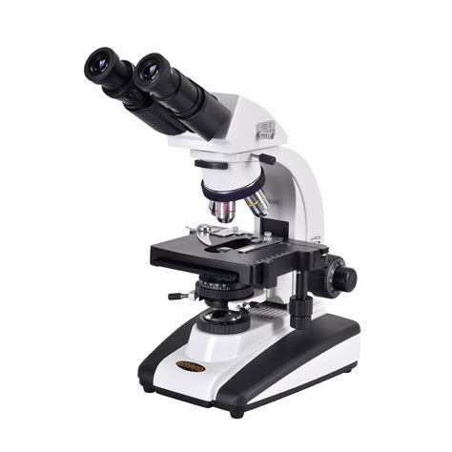
THE LEIDY MICROSCOPICAL SOCIETY’S 47th ANNUAL MICROMOUNT SYMPOSIUM MARCH 10 & 11

The Leidy Microscopical Society hosts its 47th Annual Micomount Symposium on Friday, March 10 and Saturday, March 11th in the narthex at Advent Lutheran Church

Advent members interested in rocks and minerals may want to check this out:
SPEAKERS:
FRIDAY: "Microscopy of Solar Wind Particles Trapped in Lunar Surface Minerals"
By Brittany A. Cymes, Ph.D.
SATURDAY: "Mineral Analysis for the Micro-Mineral Collector"
By Robert A. Carlton, Ph.D.

*Silent Auctions* Give-Away Tables*
Friday March 10, Noon - 6:00 pm & Saturday March 11, 9:00 am to 6:00 pm.

Visitor's Fee: $5.00 for Friday, $10.00 for Saturday – includes lunch.

Questions: Email donmcalarnen@outlook.com Phone: 610 - 584-1364
Make checks payable to Don McAlarnen, 916 Senator Road, Norristown, PA 19403
or pay when you attend.


EASTER LILIES
The sign-up sheet to place Easter Lilies on the alter for Easter Sunday is on the table in the narthex until April 2. Cost is $15 per plant. You can call or email the office with your request 215-355-2529/office@adventrichboro.org.

VACATION BIBLE SCHOOL JULY 24 – 28


The dates have been set for Vacation Bible School at Advent this summer!
The week of July 24 – 28, Monday - Friday from 9:00 a.m.–noon will
feature OPERATION RESTORATION for students age 4 through completion of grade 6. Learning with friends makes Bible School fun! As they make connections between Bible stories and actions, they’ll discover simple ways to live out faith in daily life, such as feed, heal, forgive, pray and rest. Students will employ art, music, science and storytelling in this creative program, along with outdoor play and a snack each day! Registration forms will be available on March 12.

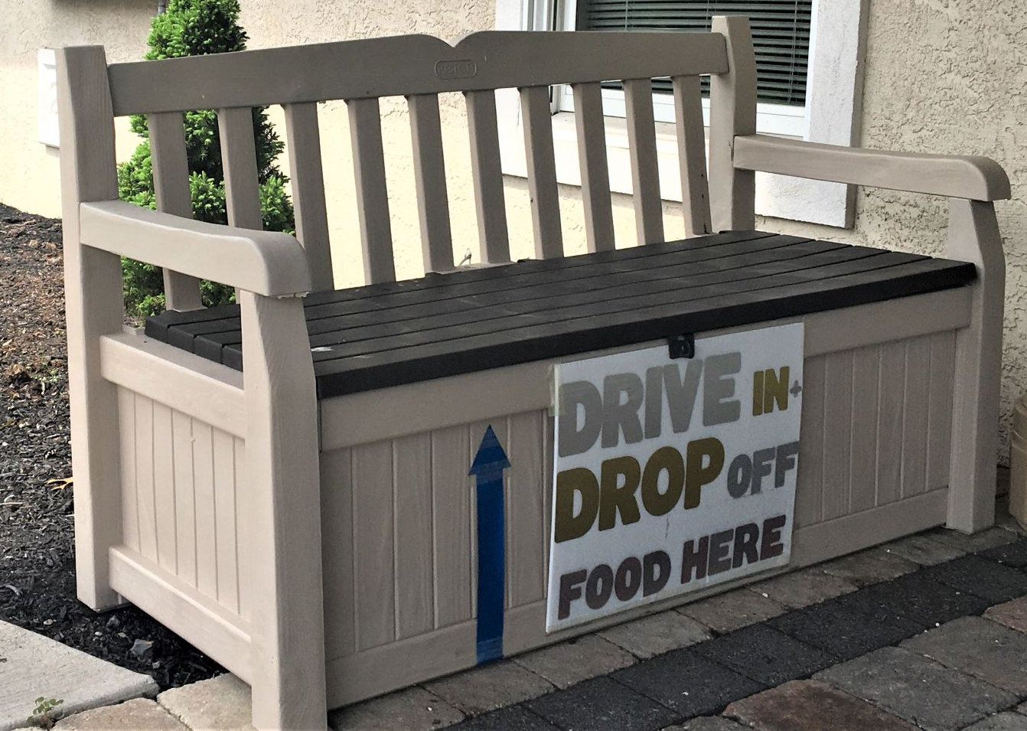
DRIVE in AND DROP off FOOD COLLECTION

If you have food for the Warminster Food Pantry that you or your friends would like to donate, and the church is not open, just drive in and drop off the food under the seat of the bench outside the front door. You may still bring food into the church narthex during church and office hours. For suggestions on which items are requested each week, go to:
www.warminsterfoodbank.org.


FELLOWSHIP TIME

We need committees or individuals to sign up to provide refreshments after the 9:30 a.m. service. The sign-up sheet through August is on the fellowship table. Advent supplies hot beverages (i.e., coffee & tea) and all paper products.

ALTAR FLOWER DEDICATION

There are numerous dates available for 2023 to dedicate flowers to beautify the altar each Sunday. Please sign up on the sheet on the table in the narthex with your name and dedication. Two bouquets are available each week. The cost is $25 per bouquet. In addition to making the altar more beautiful, you take the flowers home after the late service to enjoy during the week. If you have any questions call Cindy Frey 267-205-0713.


STITCH CLUB ITEMS AVAILABLE

Stitch club items are available throughout the year. If you need any of the items made by
the Stitch Club, i.e., blankets, hats, baby items, please contact Hanna McCollum 215-962-
9032 or Jeff Jobes 215-355-4149.

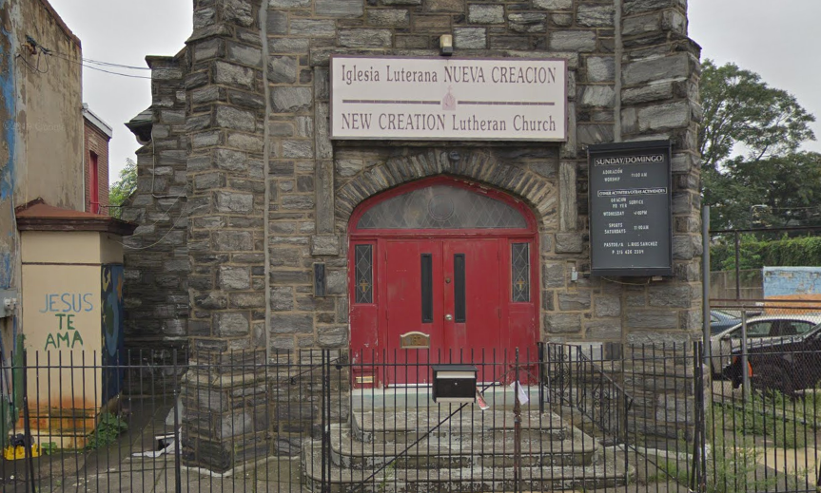

NUEVA CREACION LUTHERAN CHURCH

Please consider supporting our sister congregation, Nueva Creación Lutheran Church in Philadelphia who does vital ministry in North Philadelphia. A sign-up sheet is found on the table in the narthex near the entrance to the sanctuary. The cost to support the Mission week is $25.00. There are openings available through the end of the year.



THE ARMED FORCES

Please keep in your prayers all our service men and women and especially those related to our congregation:

Colonel Andrew M Frey, Jr is serving as Command Center Director, NORAD/NORTHCOM, stationed at Peterson SFB, Colorado Springs, CO
US Army Ranger Liam McKendry, grandson of Pastor Jo Wright stationed in Fort Benning, GA
PFC Joseph Vanderstine, grandson of Alan and Rhona Slawter serving in the Middle East.

If there are any errors or omissions, please notify the church office. Thank you.

FINANCIAL UPDATE
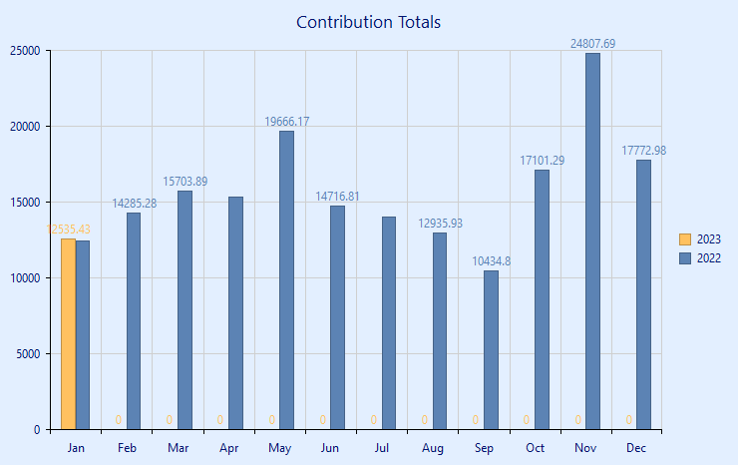

Financial Report for January 2023
 | Received as of 1/31/23 |  | Needed per Budget as of  1/31/23
Current | $11,802.43 |  | $17,281.00
Mortgage | $2,581 |  | $1,898.00
Bene. - Synod Only | $110 |  | $134
Other Benevolence | $285
Total | $14,778.43 |  | $19,313.00

Thanks to everyone for your continued financial support of the church this year. We greatly appreciate it. They are numerous ways to continue your offerings.
- Drop off your offering at the church office. The office is usually open on Tuesday, Wednesday and Thursday between 10 AM and 1 PM. Call to confirm hours.
- Mail a check to the church. The mailing address is “Advent Lutheran Church, PO Box 840, Richboro, PA 18954”
- Contribute online at www.adventrichboro.org. At the top of the page, click the “Give Now” link to see frequently asked questions. At the bottom of the page click the “Give Now” link for our Giving platform. You may also choose to set up recurring donations or a one-time donation.
Again, thank you for your continued support. If you have any questions concerning your offering please call Cindy Frey, Financial Secretary 267-205-0713

SERVING IN WORSHIP – MARCH 2023 SCHEDULE

8:00 A.M. LAY READERS COMMUNION ASSISTANTS

3/05 Open Hanna McCollum
3/12 Rose Herbert Rose Herbert
3/19 Open Open
3/26 David Elkin Janice Hoffman

9:30 A.M. LAY READERS COMMUNION ASSISTANTS

3/05 Jennifer McQuiggan Jennifer McQuiggan

3/12 Gail Oines Gail Oines
3/19 John Flint John Flint
3/26 Open Open

OUR TECH CREW
Pastor Matt, Mike Dettra, Tony Gryszka, Gary Zimmerman

ALTAR GUILD
8:00 A.M. Hanna McCollum
9:30 A.M. Gail Oines, Nancy Sclight, Rhona Slawter

FLOWER DISTRIBUTION
Linda Brownlee, Audrey Savchuck, Nancy Sclight, Rhona Slawter


FEBRUARY 26

26 John Flint

MARCH

5 Justin Segal
10 David Breig

18 Andy Stirzel
22 Sally Frost
Arielle Segal
28 Tom Herbert
30 Rachael McQuiggan

Please contact the church office if you or someone you know has been omitted from the list.
Thank you.



Sunday | Monday | Tuesday | Wednesday | Thursday | Friday | Saturday
 |  |  | 1  6:30 Praise Band  7:15 Vocal Choir | 2  6:00 P.M. Soup Supper  7:00 P.M. Lenten  Worship Service | 3 | 4  10:00 AM -Noon Stitch Club
5  2nd Sunday in Lent  8:00 AM Traditional  Holy Communion  9:00 AM Adult Bible Study  9:30 AM Contemporary  Holy Communion  Sunday School age 4 - gr. 6  10:30 AM Fellowship Time:  George Henry  10:45 AM Adult Bible Study | 6  7:30 PM  A.A. Open Meeting | 7  6:30 – 8:00 PM  Ping Pong | 8 | 9  6:00 P.M. Soup Supper  7:00 P.M. Lenten  Worship Service | 10  .7:30 PM A.A. Step Mtg  12:00 pm-6:00pm  LEIDY MICROSCOPICAL SOCIETY  see pg. 5 | 11  8:30 AM Men’s Breakfast  9:00 am-6:00 pm  LEIDY MICROSCOPICAL SOCIETY  see pg. 5  10:00 AM-Noon Stitch Club
12  3rd Sunday in Lent  8:00 AM Traditional  Holy Communion  9:00 AM Adult Bible Study  9:30 AM Contemporary  Holy Communion  Sunday School age 4 - gr. 6  10:30 AM Fellowship Time:  The Dettra Family  10:45 AM Church Council Meeting | 13  7:30 PM  A.A. Open Meeting | 14  6:30 – 8:00 PM  Ping Pong | 15  6:30 Praise Band  7:15 Vocal Choir | 16  6:00 P.M. Soup Supper  7:00 P.M. Lenten  Worship Service | 17  7:30 PM A.A. Step Mtg.   | 18  10:00 AM-Noon Stitch Club
19  4th Sunday in Lent  8:00 AM Traditional  Holy Communion  9:00 AM Adult Bible Study  9:30 AM Contemporary  Holy Communion  Sunday School age 4 - gr. 6  10:30 AM Fellowship Time: Open  10:45 AM Adult Bible Study | 20  7:30 PM  A.A. Open Meeting | 21  6:30 – 8:00 PM  Ping Pong | 22 | 23  6:00 P.M. Soup Supper  7:00 P.M. Lenten  Worship Service | 24  7:30 PM A.A. Step Mtg. | 25  10:00 AM-Noon Stitch Club
26  5th Sunday in Lent  8:00 AM Traditional  Holy Communion  9:00 AM Adult Bible Study  9:30 AM Contemporary  Holy Communion  Sunday School age 4 - gr. 6  10:30 AM Fellowship Time: Open  10:45 AM Adult Bible Study | 27  7:30 PM  A.A. Open Meeting | 28  6:30 – 8:00 PM  Ping Pong | 29  6:30 Praise Band  7:15 Vocal Choir | 30  6:00 P.M. Soup Supper  7:00 P.M. Lenten  Worship Service | 31  7:30 PM A.A. Step Mtg.

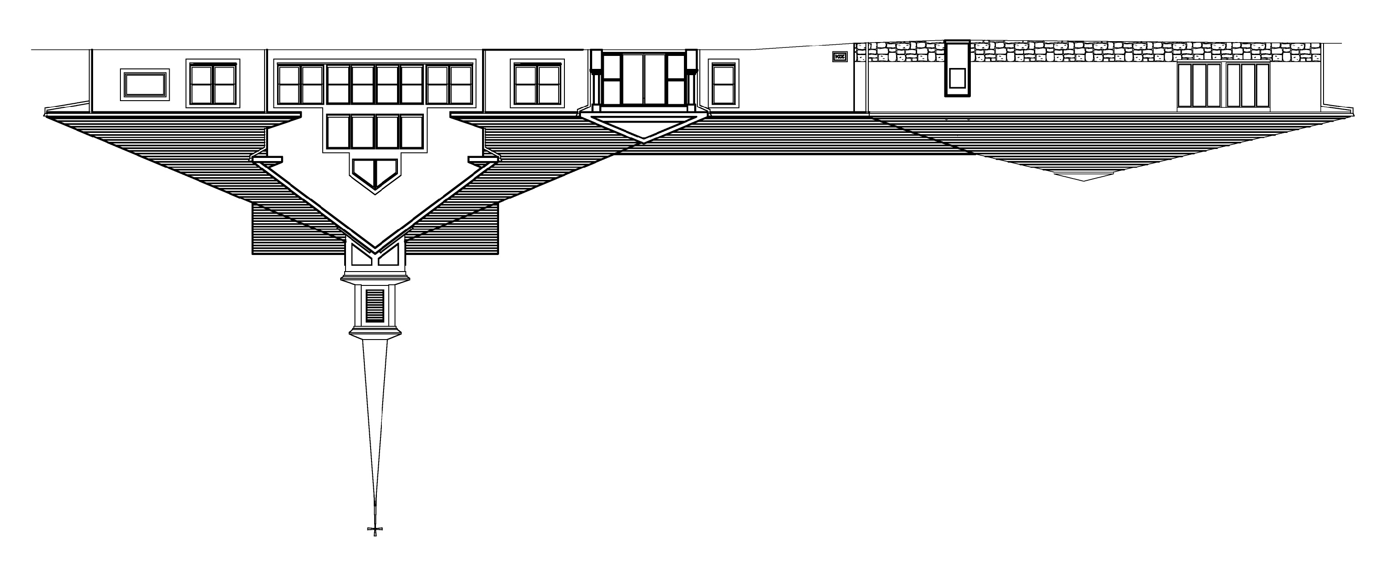

Advent Evangelical Lutheran Church
45 Worthington Mill Rd
P.O. Box 840
Richboro, PA18954-0840

Address Service Requested

