**Second Sunday in Lent**

**March 5, 2023**

**8:00 a.m.**

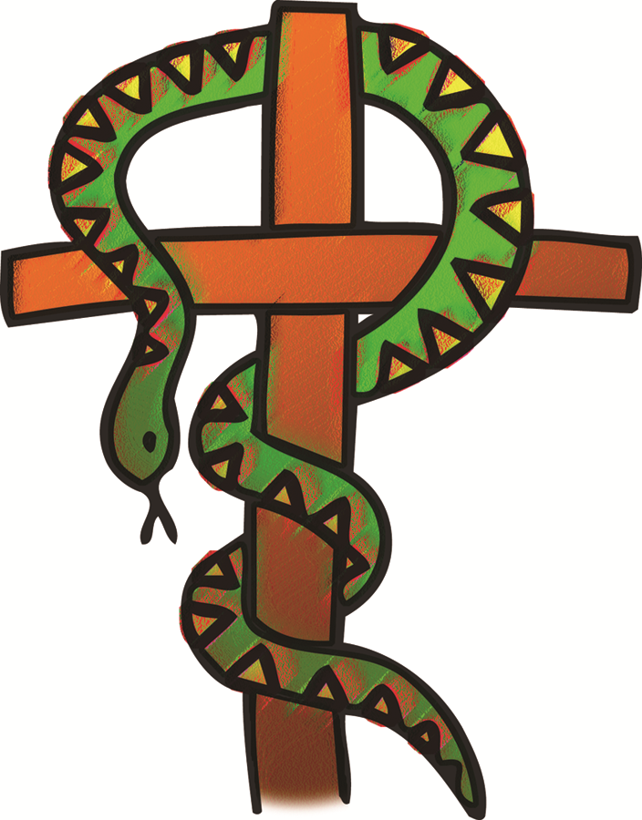

***LUTHERAN BOOK OF WORSHIP***

***SETTING ONE***

***ORDER OF WORSHIP***

***GATHERING***

***Prelude*** *(a time for silent meditation)*

***Announcements***

***Confessions and Forgiveness***

In the name of the Father, and of the † Son, and of the Holy Spirit.

**Amen.**

Almighty God, to whom all hearts are open, all desires known, and from whom no secrets are hid: Cleanse the thoughts of our hearts by the inspiration of your Holy Spirit, that we may perfectly love you and worthily magnify your holy name, through Jesus Christ our Lord.

**Amen.**

If we say we have no sin, we deceive ourselves, and the truth is not in us. But if we confess our sins, God who is faithful and just will forgive our sins and cleanse us from all unrighteousness.

*Silence is kept for reflection.*

Most merciful God,

**we confess that we are in bondage to sin and cannot free ourselves. We have sinned against you in thought word and deed, by what we have done and by what we have left undone. We have not loved you with our whole heart; we have not loved our neighbors as ourselves. For the sake of your Son, Jesus Christ, have mercy on us. Forgive us, renew us, and lead us, so that we may delight in your will and walk in your ways, to the glory of your holy name. Amen.**

Almighty God, in his mercy, has given his Son to die for us and, for his sake, forgives us all our sins. As a called and ordained minister of the Church of Christ, and by his authority, I therefore declare to you the entire forgiveness of all your sins, in the name of the Father, and of the † Son, and of the Holy Spirit. **Amen.**

***Gathering Hymn:* “Lift High the Cross*” LBW #377***

*Refrain*

Lift high the cross, the love of Christ proclaim

till all the world adore his sacred name.

1 Come, Christians, follow where our captain trod,

Our king victorious, Christ, the Son of God. *Refrain*

2 Led on their way on this triumphant sign.

The hosts of God in conquring ranks combine. Refrain

3 All newborn servants of the Crucified

Bear on their brows the seal of him who died. *Refrain*

4 O Lord, once lifted on the glorious tree,

As thou hast promised, draw us all to thee. *Refrain*

***Greeting***

The grace of our Lord Jesus Christ, the love of God,

and the communion of the Holy Spirit be with you all.

**And also with you.**

***Kyrie***

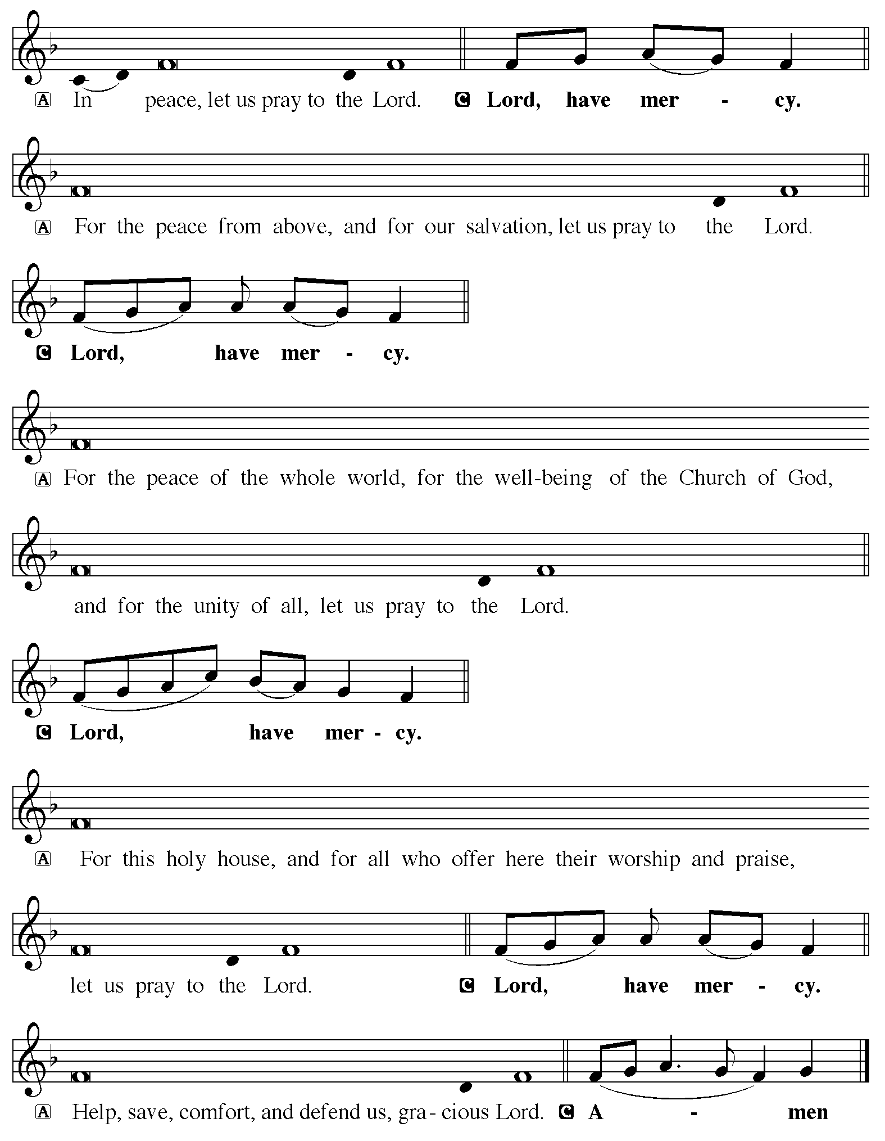



***Prayer of the Day***

Let us pray . . . O God, our leader and guide, in the waters of baptism you bring us to new birth to live as your children. Strengthen our faith in your promises, that by your Spirit we may lift up your life to all the world through your Son, Jesus Christ, our Savior and Lord, who lives and reigns with you and the Holy Spirit, one God, now and forever.

**Amen.**

***Word***

God speaks to us in scripture reading, preaching, and song.

### *First Reading: Genesis 12:1-4a*

1The Lord said to Abram, “Go from your country and your kindred and your father’s house to the land that I will show you. 2I will make of you a great nation, and I will bless you, and make your name great, so that you will be a blessing. 3I will bless those who bless you, and the one who curses you I will curse; and in you all the families of the earth shall be blessed.”  
 4aSo Abram went, as the Lord had told him; and Lot went with him.

Word of God, Word of Life

**Thanks be to God**

### Psalm: Psalm 121

### 1I lift up my eyes to the hills;   from where is my help to come?  2My help comes from the Lord,   the maker of heaven and earth.  3The Lord will not let your  foot be moved   nor will the one who watches over you fall asleep.  4Behold, the keeper of Israel   will neither slumber nor sleep;   5the Lord watches over you;   the Lord is your shade at your right hand;  6the sun will not strike you by day,   nor the moon by night.  7The Lord will preserve you from all evil   and will keep your life.  8The Lord will watch over your going out and your coming in,   from this time forth forevermore.

### *Second Reading: Romans 4:1-5, 13-17*

1What then are we to say was gained by Abraham, our ancestor according to the flesh? 2For if Abraham was justified by works, he has something to boast about, but not before God. 3For what does the scripture say? “Abraham believed God, and it was reckoned to him as righteousness.” 4Now to one who works, wages are not reckoned as a gift but as something due. 5But to one who without works trusts him who justifies the ungodly, such faith is reckoned as righteousness.  
 13For the promise that he would inherit the world did not come to Abraham or to his descendants through the law but through the righteousness of faith. 14If it is the adherents of the law who are to be the heirs, faith is null and the promise is void. 15For the law brings wrath; but where there is no law, neither is there violation.  
 16For this reason it depends on faith, in order that the promise may rest on grace and be guaranteed to all his descendants, not only to the adherents of the law but also to those who share the faith of Abraham (for he is the father of all of us, 17as it is written, “I have made you the father of many nations”)—in the presence of the God in whom he believed, who gives life to the dead and calls into existence the things that do not exist.

Word of God, Word of Life

**Thanks be to God**

***Gospel Acclamation***

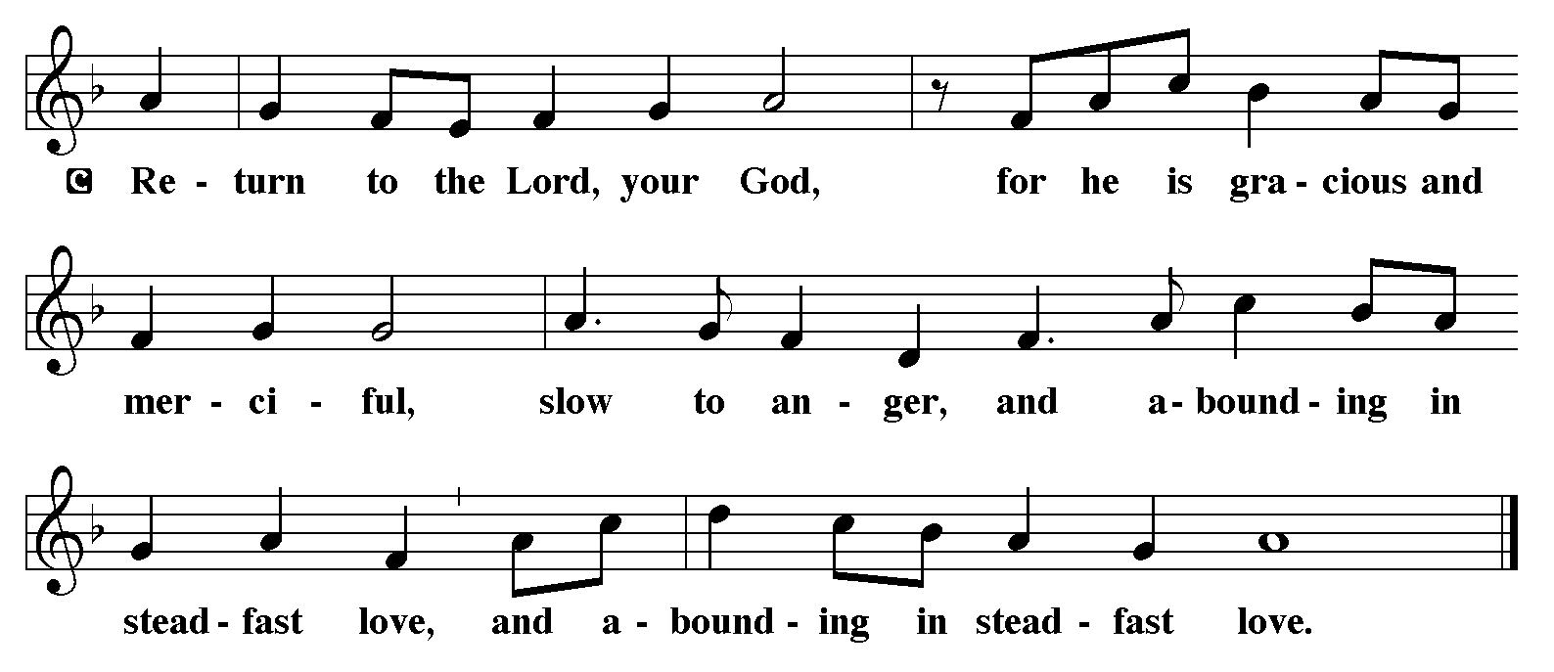

### Gospel Reading: John 3:1-17 announces the reading of the Gospel. The congregation responds.)

**P:** The Holy Gospel according to John the 3rd Chapter

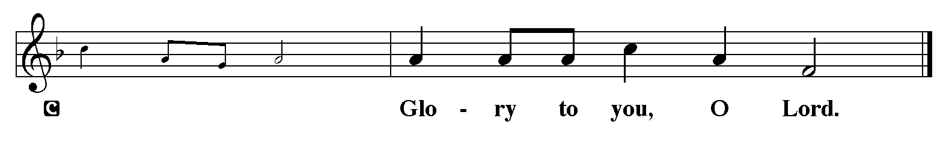

1Now there was a Pharisee named Nicodemus, a leader of the Jews. 2He came to Jesus by night and said to him, “Rabbi, we know that you are a teacher who has come from God; for no one can do these signs that you do apart from the presence of God.” 3Jesus answered him, “Very truly, I tell you, no one can see the kingdom of God without being born from above.” 4Nicodemus said to him, “How can anyone be born after having grown old? Can one enter a second time into the mother’s womb and be born?” 5Jesus answered, “Very truly, I tell you, no one can enter the kingdom of God without being born of water and Spirit. 6What is born of the flesh is flesh, and what is born of the Spirit is spirit. 7Do not be astonished that I said to you, ‘You must be born from above.’ 8The wind blows where it chooses, and you hear the sound of it, but you do not know where it comes from or where it goes. So it is with everyone who is born of the Spirit.” 9Nicodemus said to him, “How can these things be?” 10Jesus answered him, “Are you a teacher of Israel, and yet you do not understand these things?  
 11“Very truly, I tell you, we speak of what we know and testify to what we have seen; yet you do not receive our testimony. 12If I have told you about earthly things and you do not believe, how can you believe if I tell you about heavenly things? 13No one has ascended into heaven except the one who descended from heaven, the Son of Man. 14And just as Moses lifted up the serpent in the wilderness, so must the Son of Man be lifted up, 15that whoever believes in him may have eternal life.

16“For God so loved the world that he gave his only Son, so that everyone who believes in him may not perish but may have eternal life.  
 17“Indeed, God did not send the Son into the world to condemn the world, but in order that the world might be saved through him. “Son of Man has been raised from the dead.”

**P:** The Gospel of the Lord.

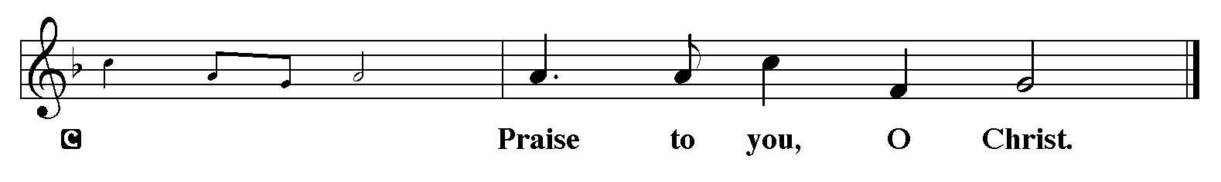

***Sermon***

**Hymn of the Day: “My Song is Love Unknown” LBW 94**

1 My song is love unknown,

my Savior’s love to me,

love to the loveless shown,

that they might lovely be.

Oh, who am I, that for my sake

my Lord should take frail flesh and die?

My Lord should take frail flesh and die?

2 He came from his blest throne,

salvation to bestow;

but men made strange, and none

the longed-for Christ would know.

But, oh, my friend, my friend indeed,

who at my need his life did spend;

who at my need his life did spend!

3 Sometimes they strew his way

and his sweet praises sing;

resounding all the day

hosannas to their King.

Then “Crucify!” is all their breath,

and for his death they thirst and cry,

and for his death they thirst and cry.

4 Why, what hath my Lord done?

What makes this rage and spite?

He made the lame to run,

he gave the blind their sight.

Sweet injuries! Yet they at these

themselves displease, and ’gainst him rise;

themselves displease, and ’gainst him rise.

***Apostles Creed***

**I believe in God, the Father almighty, creator of heaven and earth.**

**I believe in Jesus Christ, his only Son, our Lord. He was conceived by the power of the Holy Spirit and born of the virgin Mary. He suffered under Pontius Pilate, was crucified, died, and was buried. He descended into hell. On the third day he rose again. He ascended into heaven, and is seated at the right hand of the Father, He will come again to judge the living and the dead.**

**I believe in the Holy Spirit, the holy catholic church, the communion of saints, the forgiveness of sins, the resurrection of the body, and the life everlasting. Amen.**

***Prayers of Intercession***:

Each prayer ends with . . . Merciful God, the congregation responds: **receive our prayer.**

***Sharing of the Peace*:**

The peace of the Lord be with you always.

**And also with you.**

***The Offering*** *Please leave your offering on our website:* <https://www.eservicepayments.com/cgi-bin/Vanco_ver3.vps?appver3=Dc8dzPGn4-LCajFevTkh9MYPCImH2sG-jdxWYJMFGW_lQfxkD4hBw8W0Q6UZLveQvLkSxosar2o939JWiAad87o7zqy-JU_UuLu19bUbJx2MmPFcXvWIUz6A7FDgkhUKk0PpduXvnt8gXUeZjQYbn9G3frHWC59Y_VCHQ6_VCoE=&ver=3>

***The Offertory***

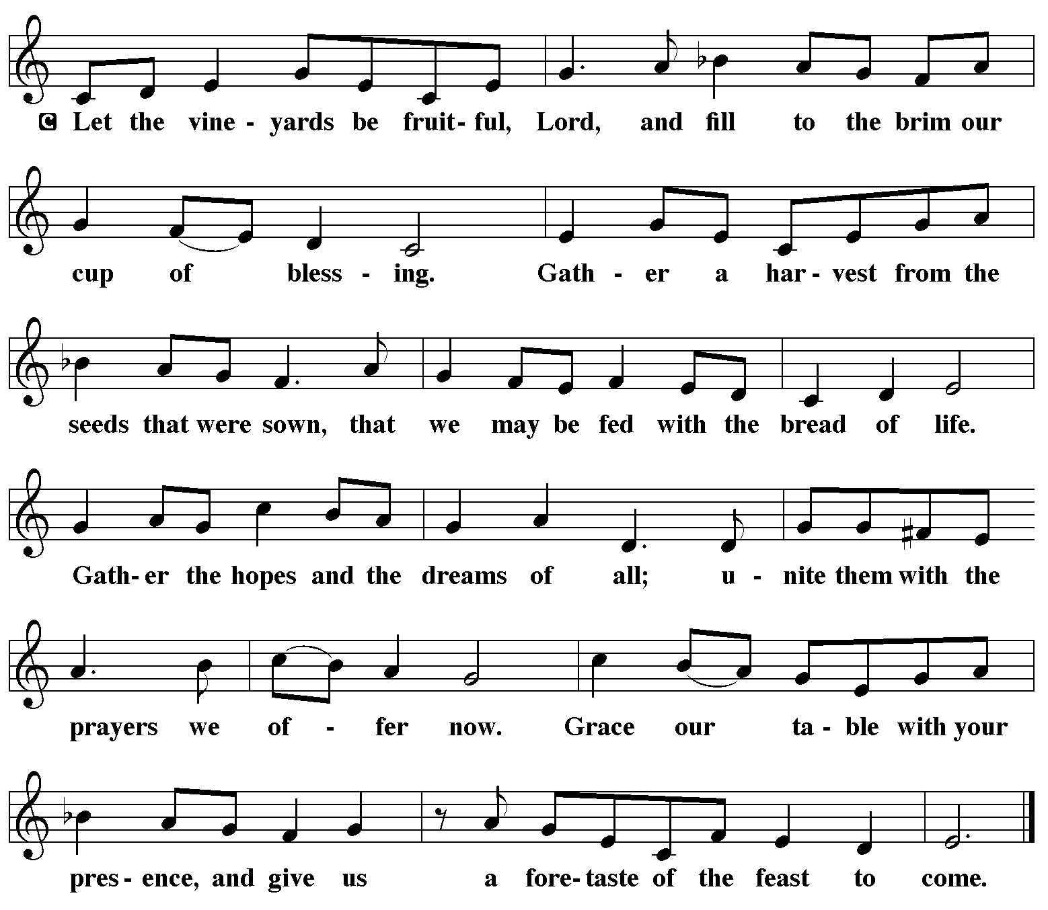

***Offertory Prayer***

Let us pray… Merciful Father,

**we offer with joy and thanksgiving what you have first given us - ourselves, our time, and our possessions, signs of your gracious love. Receive them for the sake of him who offered himself for us, Jesus Christ our Lord. Amen.**

***SACRAMENT***

***The Great Thanksgiving***

The Lord be with you.

**And also with you.**

Lift up your hearts.

**We lift them to the Lord.**

Let us give thanks to the Lord our God.

**It is right to give our thanks and praise.**

It is indeed right, our duty and our joy... *(preface continues with words for the season and concludes...)* we praise your name and join their unending hymn:

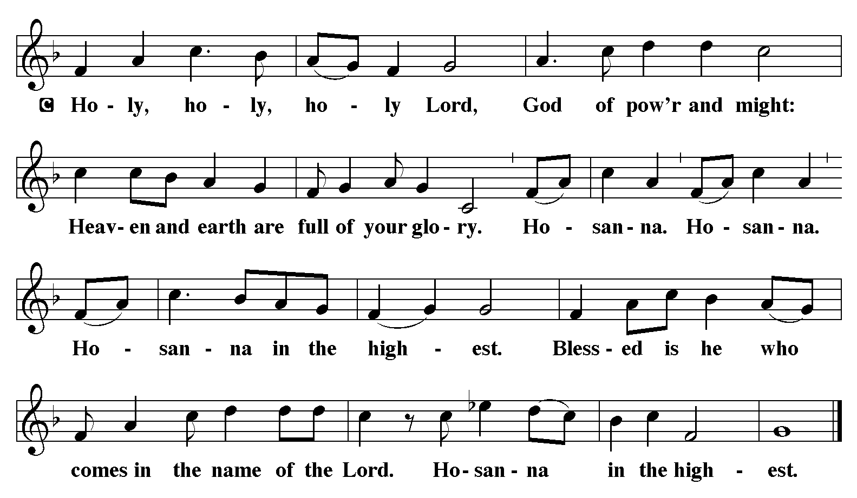

Holy One, the beginning and the end, the giver of life:

Blessed are you for the birth of creation.

Blessed are you in the darkness and in the light.

Blessed are you for your promise to your people.

Blessed are you in the prophets’ hopes and dreams.

Blessed are you for Mary’s openness to your will.

Blessed are you for your Son Jesus,

the Word made flesh.

In the night in which he was betrayed,

our Lord Jesus took bread, and gave thanks;

broke it, and gave it to his disciples, saying:

Take and eat; this is my body, given for you.

Do this for the remembrance of me.

Again, after supper, he took the cup, gave thanks,

and gave it for all to drink, saying:

This cup is the new covenant in my blood,

shed for you and for all people for the forgiveness of sin.

Do this for the remembrance of me.

Let us proclaim the mystery of faith:

**Christ has died.**

**Christ is risen.**

**Christ will come again.**

With this bread and cup

we remember your Word dwelling among us,

full of grace and truth.

We remember our new birth in his death and resurrection.

We look with hope for his coming.

**Come, Lord Jesus.**

Holy God, we long for your Spirit.

Come among us.

Bless this meal.

May your Word take flesh in us.

Awaken your people.

Fill us with your light.

Bring the gift of peace on earth.

**Come, Holy Spirit.**

All praise and glory are yours,

Holy One of Israel,

Word of God incarnate,

Power of the Most High,

one God, now and forever.

**Amen.**

***Lord’s Prayer***

Lord, remember us in your kingdom and teach us to pray.

**Our Father, who art in heaven,**

**hallowed be thy name,**

**thy kingdom come,**

**thy will be done,**

**on earth as it is in heaven.**

**Give us this day our daily bread;**

**and forgive us our trespasses,**

**as we forgive those**

**who trespass against us;**

**and lead us not into temptation,**

**but deliver us from evil.**

**For thine is the kingdom,**

**and the power, and the glory,**

**forever and ever. Amen.**

***Invitation to Communion***

Come to the table. Feast on God's abundant life for you.

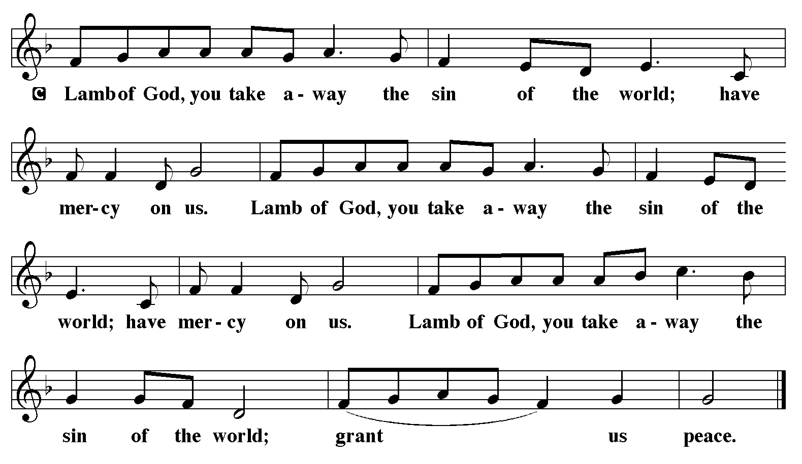

***Distribution***

The body of Christ, given to you.

The blood of Christ, shed for you.

***Post-Communion Blessing***

The body and blood of our Lord Jesus Christ strengthen you and keep you in his grace.

**Amen.**

***Post-Communion Canticle***

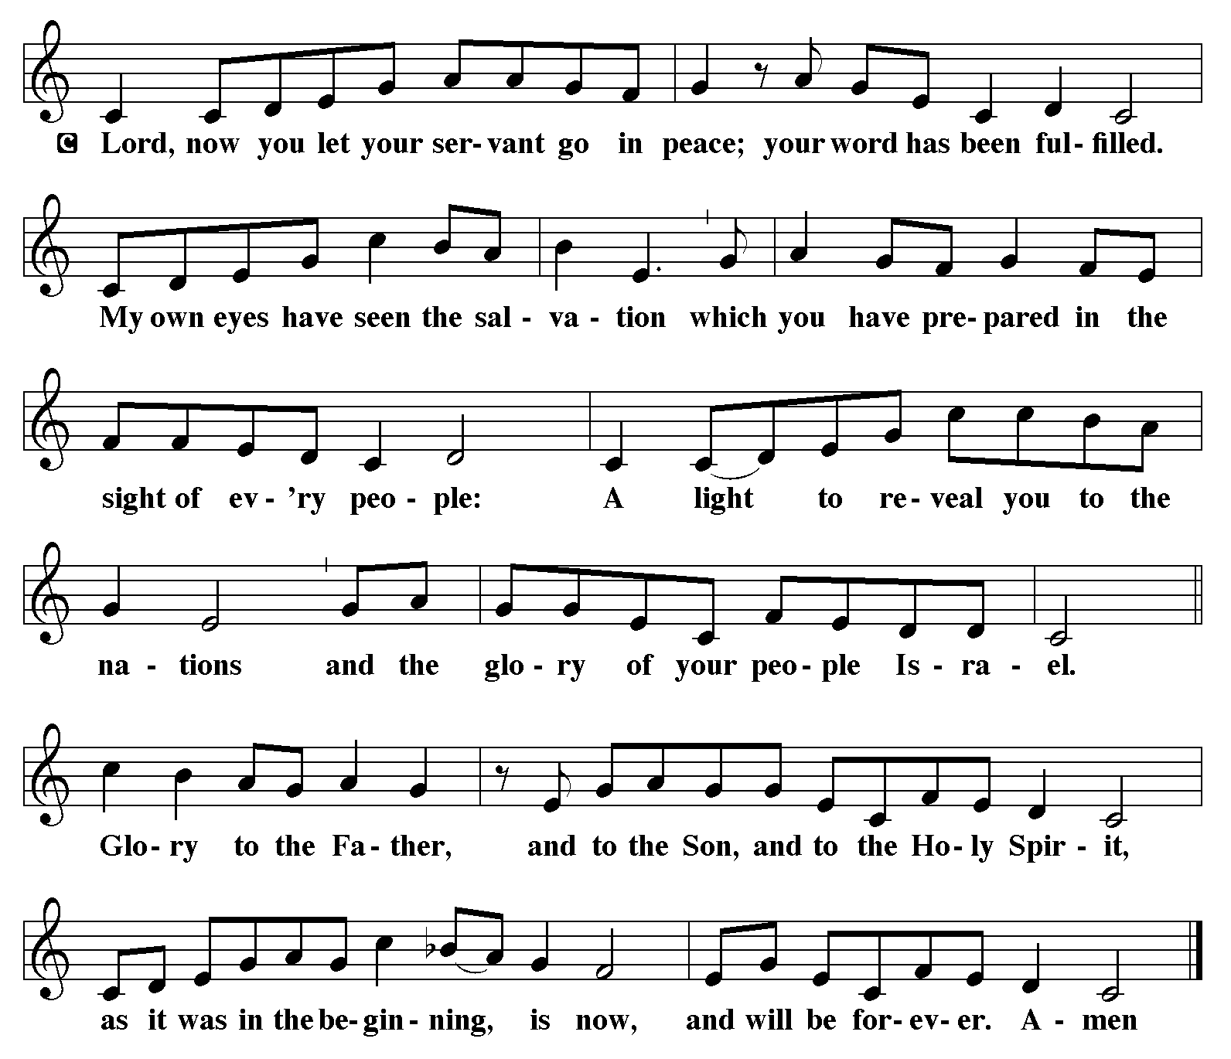

***Prayer after Communion***

Let us pray… **Faithful God,**

**in this meal you have remembered your mercy,**

**bringing heaven to earth in the body and blood of Christ.**

**As we wait for the day when all your promises will be fulfilled,**

**sustain us and strengthen us by this holy mystery.**

**Guide us toward your promised future, coming to birth in Jesus Christ**

**our Savior and Lord.**

**Amen.**

***SENDING***

***Benediction***

The Lord bless you and keep you.

The Lord make his face shine on you

and be gracious to you.

The Lord look upon you with favor

and + give you peace.

**Amen.**

***Sending Song: “How firm a Foundation” LBW #507***

1 How firm a foundation, O saints of the Lord,

is laid for your faith in his excellent word!

What more can he say than to you he has said

who unto the Savior for refuge have fled?

2 “Fear not, I am with you, oh, be not dismayed,

or I am your God and will still give you aid;

I’ll strengthen you, help you, and cause you

to stand, upheld by my righteous, omnipotent hand.

3 “When through fiery trials your pathway shall lie,

my grace, all-sufficient, shall be your supply.

The flames shall not hurt you; I only design

your dross to consume and your gold to refine.

4 “Throughout all their lifetime my people shall prove

my sov’reign, eternal, unchangeable love;

and then, when gray hairs shall their temples adorn,

like lambs they shall still in my bosom be borne.”

***Dismissal***

**Go in peace. Love your neighbor.**

**Thanks be to God.**

*Some content copyright by Augsburg Fortress and used by permission. SundaysandSeasons.com License SB151685.*

CCLI License:266554

**OUR MISSION – FAITHFUL IN THE WORD**

**+** To ***gather*** as God’s people and nurture one another

**+** To ***know*** the Word of God

**+** To ***grow*** in faith, love, and service

**+** To ***go*** into the world with the Good News of Jesus Christ



SERVING OUR LORD IN WORSHIP TODAY

Pastor: The Rev. Matthew E Ollikainen

Music Director Michael Dettra

Lay Reader Open

Communion Assistant Hanna McCollum

#### 

**ALTAR FLOWERS**

The Altar Flowers are presented by Janice Hoffmann in memory of her father, Howard L. Bobb, Sr. and by Hanna McCollum in memory of her husband.

**NUEVA CREACIÓN MISSION SUPPORT**

Please consider supporting our sister congregation, Nueva Creación Lutheran Church in Philadelphia which does vital ministry in North Philadelphia. A sign-up sheet is found on the table in the narthex near the entrance to the sanctuary.

**WORSHIP ATTENDANCE:**

Ash Wednesday 12:00pm 10 7:00 pm 10 Total 20

Sunday, February 26, 9:00 am Total 39

Congregational Meeting February 26, 10:00 am Total 29

**MONTHLY FINANCIAL STATEMENT**

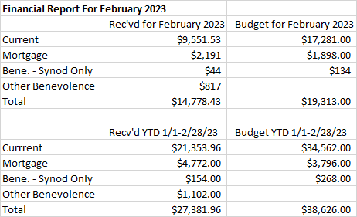

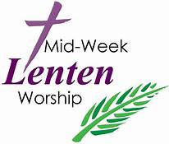**MID-WEEK LENTEN WORSHIP SERVICES THURSDAYS MARCH 2 - MARCH 30, 7 PM**

### *Beneath the Cross of Jesus* is the theme for worship this season of Lent. We live our lives beneath the cross of Jesus, beneath God’s manifold love and grace that reach to us even from Calvary. Based on the hymn “Beneath the cross of Jesus” (ELW 338), this series explores what it means for us to abide at the foot of the cross, to cling to the rock of our salvation, to dwell in the house of the Lord, and to confess our sins and receive God’s forgiveness.

Services will be held in person and online Thursday **evenings at 7:00 p.m., March 2 through March 30.**

Mid-week Lenten Worship services may also be attended by **Zoom** and will be live streamed on **Facebook**.  A recording of the services will be uploaded to **YouTube** and linked to our website immediately after the service concludes.

While using Zoom, please mute yourself when you are not speaking.

Meeting ID: 864 7772 3021

Pass code: 443360

[https://us02web.zoom.us/j/86477723021?pwd=cEFHd2hxY0xMRVJPT2hCQjQ5MnF2Zz09](https://us02web.zoom.us/j/86477723021?pwd=cEFHd2hxY0xMRVJPT2hCQjQ5MnF2Zz09 )

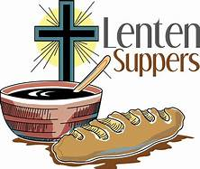**MID-WEEK LENTEN SOUP SUPPERS**

Gather at church during the season of Lent for soup and fellowship before the mid-week Lenten worship service.  The Soup Suppers will begin at **6:00 p.m**. in the social hall on **Thursdays** March 2 through March 30.  Please sign up at church to bring soup, bread or drinks. Please contact Gail Oines with any questions or concerns 215-534-8218.



**MEN’S BREAKFAST SATURDAY, MARCH 11**

Men's breakfast will take place Saturday, March 11 at 8:30 am. This will be our St. Patrick’s Day breakfast.

We plan an old favorite, even though it is not green (we hope). We start serving at 8:30 a.m., coffee is ready and waiting at 7:30. Dave



**THE LEIDY MICROSCOPICAL SOCIETY’S 47th  ANNUAL MICROMOUNT SYMPOSIUM MARCH 10 & 11**

The Leidy Microscopical Society hosts its 47th Annual Micromount Symposium on Friday, March 10 and Saturday, March 11th in the narthex at Advent Lutheran Church

Advent members interested in rocks and minerals may want to check this out:

**SPEAKERS:**

FRIDAY: "Microscopy of Solar Wind Particles Trapped in Lunar Surface Minerals"

By Brittany A. Cymes, Ph.D.

SATURDAY: "Mineral Analysis for the Micro-Mineral Collector"

By Robert A. Carlton, Ph.D.

*Silent Auctions* Give-Away Tables*

Friday March 10, Noon - 6:00 pm & Saturday March 11, 9:00 am to 6:00 pm.

Visitor's Fee: $5.00 for Friday, $10.00 for Saturday – includes lunch.

Questions: Email [donmcalarnen@outlook.com](mailto:donmcalarnen@outlook.com) Phone: 610 - 584-1364

Make checks payable to Don McAlarnen, 916 Senator Road, Norristown, PA 19403

or pay when you attend.

**LUTHERAN WORLD RELIEF - EARTHQUAKE IN TURKEY**

Lutheran World Relief is coordinating an emergency response to our neighbors in Turkey devastated by the earthquake.

We are being asked to donate to the emergency response fund so they can deliver critically needed care for families like water, medical care, shelter and essential supplies.

Please send your donations to Advent marked with earthquake relief and it will be sent in to Lutheran World Relief or give online at **lwr.org/quake** or mail a check to **Lutheran World Relief, PO Box 17061, Baltimore, MD 21297-1061**. Please write QUAKE in the memo.

Thank you for leading our congregation to share God's love with the world when it's needed most.

**CHOIR AND PRAISE BAND PRACTICES**

Practices of the Choir and Praise Band are on **Wednesday evenings” March 15, 29 and April 5, 6:30 Praise Band begins at 6:30, 7:15 Vocal Choir.** All are welcome and encouraged to join, no prior experience is necessary. Please see Mike Dettra, Music Director or Pastor Matt for more details.

**PING PONG TUESDAY NIGHTS**

We are playing Ping Pong weekly on Tuesday nights, starting at **6:30 pm** and ending around 8 pm. All are invited. No equipment is required. Please contact Ray Heiss if you plan to give it a try ([rayheiss1@gmail.com](mailto:rayheiss1@gmail.com))

**STITCH CLUB, SATURDAYS 10:00 A.M.**

Stitch club meets on Saturdays **at 10:00 a.m.** Stitch club is open to all who would like to join. If you like to knit, crochet, or do needlepoint, this is for you!

If you would need anything **throughout the year** from the Stitch Club for babies or the elderly i.e. blankets, scarves, etc., please contact Hanna McCollum at 215-962-9032 or Jeff Jobes at 215-355-4149.

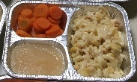

**FILL A TRAY AT MEALTIME**

Look for aluminum trays on the tables in our narthex. Take some home to await any meal that has one serving left – or perhaps you’ve made extra food on purpose!   Fill the 3 sections, add the foil cover, plus the label and bag that come with the tray.  Voila!  A meal for a shut-in or a person in need!

**THIS WEEK AT ADVENT**

**SECOND SUNDAY IN LENT - MARCH 5**

8:00 am Traditional Holy Communion

9:00 am Adult Bible Study

9:30 am Contemporary Holy Communion

Sunday School age 4 - grade 6

10:30 am Fellowship Time: George Henry

10:45 am Adult Bible Study

**MONDAY, MARCH 6**

7:30 pm A.A. Open Meeting

**TUESDAY, MARCH 7**

6:30 pm Ping Pong

**THURSDAY, MARCH 9**

6:00 pm Soup Supper

7:00 pm Lenten Worship Service

**FRIDAY, MARCH 10**

7:30 pm A.A. Step Meeting

**SATURDAY, MARCH 11**

8:30 am Men’s Breakfast

10:00 am Stitch Club

**SECOND SUNDAY IN LENT – MARCH 12**

8 :00 am Traditional Holy Communion

9:00 am Adult Bible Study

9:30 am Contemporary Holy Communion

Sunday School age 4 - grade 6

10:30 am Fellowship Time: The Dettra Family

10:45 am Church Council Meeting

#### 